CRISP-DM Research Implementation Plan: XAI Computational Efficiency

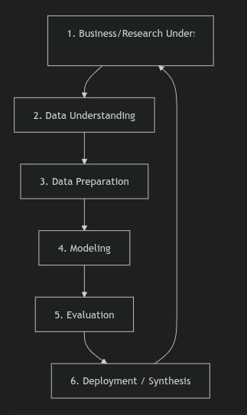
This implementation plan structures our thesis research following the CRISP-DM (Cross-Industry Standard Process for Data Mining) methodology, adapted for an academic benchmarking study.

1. Business/Research Understanding2. Data Understanding3. Data Preparation4. Modeling5. Evaluation6. Deployment / Synthesis

Phase 1: Business & Research Understanding
Goal: Define research questions, success criteria, and select the final set of models.
- Research Objective: Benchmark the computational efficiency and resource overhead of four XAI methods (LIME, Grad-CAM, SHAP, and Vanilla Saliency Maps) when explaining predictions from lightweight classifiers (MobileNetV3, ShuffleNetV2) on edge devices.
- Target Architectures:
  - MobileNetV3-Large (or Small)
  - ShuffleNetV2
- Target XAI Methods:
  - Grad-CAM: Gradient-based, specific to conv layers. Very fast.
  - Saliency Maps (Vanilla Saliency): Pure backpropagation gradients of output class with respect to the input image. Fast and lightweight.
  - LIME: Perturbation-based, surrogate model. Computationally heavy.
  - SHAP (KernelSHAP or DeepSHAP): Coalition-based game theory. Computationally heavy.
- Primary Constraints: Edge-device resources (CPU-only benchmark, peak RAM usage under 1-2 GB, battery drain).

Phase 2: Data Understanding
Goal: Acquire and inspect the dataset.
- Dataset: PlantVillage Dataset (or a subset of it, e.g., Tomato Leaf Diseases or Potato Leaf Diseases).
- Key Steps:
  - Download and verify dataset integrity.
  - Analyze class distributions (unbalanced classes can bias predictions and affect XAI interpretations).
  - Inspect image resolutions (standardizing to $224 \times 224$ pixels to match lightweight network inputs).

Phase 3: Data Preparation
Goal: Clean, preprocess, and construct data loaders.
- Standardization: Crop/resize images to $224 \times 224$.
- Normalization: Apply ImageNet-standard channel means and standard deviations.
- Splitting: Create robust Train/Validation/Test splits (e.g., 70/15/15) ensuring no data leakage.
- Augmentation: Apply rotation, flipping, and color jittering to prevent overfitting on background artifacts.

Phase 4: Modeling
Goal: Train and validate the lightweight architectures.
- Transfer Learning: Fine-tune pretrained PyTorch models (mobilenet_v3_large, shufflenet_v2_x1_0) on the plant disease dataset.
- Validation Target: Ensure the models achieve a high classification accuracy (e.g., $>90%$ validation F1-score) to ensure the explanations reflect a well-trained, reliable decision boundary.
- Save Model Weights: Export models to PyTorch checkpoint format (.pth) and ONNX format (for deployment tests).

Phase 5: Evaluation (The Core Thesis Contribution)
Goal: Run the benchmarking suite and profile computational performance.
- Latency Profiler:
  - Measure time taken to generate explanation per image across 100 runs.
  - Report latency relative to inference latency (e.g., "Grad-CAM explanation takes $1.2\times$ inference time, while LIME takes $400\times$ inference time").
- Resource Profiler:
  - Profile peak memory (RAM and VRAM) allocated during the explanation process.
  - Calculate energy consumption (using software profilers like CodeCarbon).
- Aesthetic/Visual Check: Verify quality of localization maps (do they highlight infected parts of the leaf or background noise?).

Phase 6: Deployment & Synthesis
Goal: Package findings and export models for edge deployment.
- Edge Compilation: Benchmark the execution speed of the lightweight models after compiling them to ONNX/TensorRT or PyTorch Mobile.
- Decision Matrix: Construct a final selection guide for developers/researchers showing which XAI model to use under specific latency and memory budgets.

